|  |  |
| --- | --- |
|  | Department of Computer Science and Engineering Faculty of Engineering, University of Moratuwa  **CS 2032 – Principles of Computer Communication**  B. Sc. Engineering Semester 3 |

Student Name ……………………………………………………..……………………………….. Field: **CSE**

Index No ………………………………...…….. Group ……….…… Date ………………………..

**Practical 3 : Basic Routing**

**Note:** *Submit your completed lab sheet and packet tracer file, individually. You must name them with your registration number.*

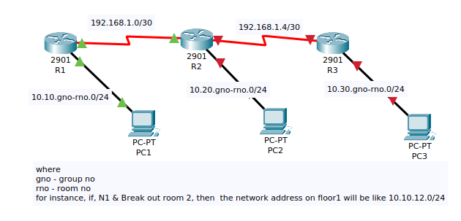

1. Create a network diagram as shown in the picture above, with proper labelling.

2. List interfaces (of routers and PCs) and IP addresses that you are planning to assign:

| Device | Interface | IP address |
| --- | --- | --- |
|  |  |  |
|  |  |  |
|  |  |  |
|  |  |  |
|  |  |  |
|  |  |  |
|  |  |  |
|  |  |  |

3. View the initial configuration of R1, State the command you used:

4. Assign IP addresses according to the above table. State the commands you used to assign IP addresses to the interfaces of R2.

5. Create IP Routes on R1, R2, and R3 to enable communications among PC1, PC2 and PC3. You can set static routes / default routes as necessary.

6. State the commands you used on R2 and R3 to set routes.

7. Copy and paste the configuration of R1 and R2 here: